Typy plodov:

A)___________________________

B)___________________________

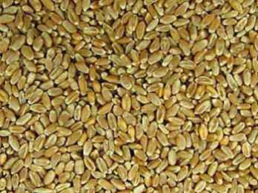

_________

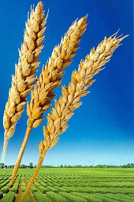



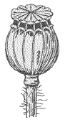

________

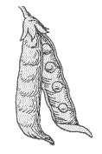

_______

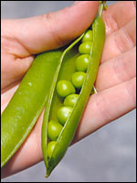

_______________________________ __________________________ ____________________________

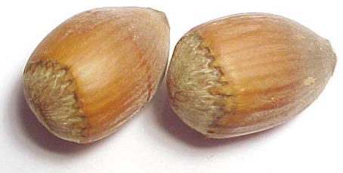

_______

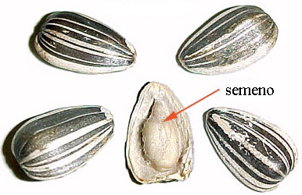

___________

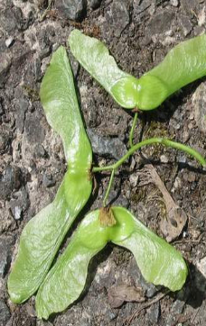

_______________________________ _____________________________ __________________________

B)

________



  